Multi-Objective Optimization
Based on Particle Swarm Optimization (PSO)

Internship Report
(Oct 2007 –Nov 2007)

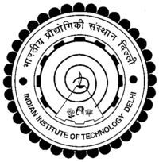

Submitted By: -
Sachidnand Swami
Department of Mathematics and Computing
Indian Institute of Technology, New Delhi

Supervised By:-

Prof. Dr.-Ing. Dominique Thévenin
Institut für Strömungstechnik & Thermodynamik
Otto-von-Guericke-Universität, Magdeburg

Dr. Gábor Janiga
Institut für Strömungstechnik & Thermodynamik
Otto-von-Guericke-Universität, Magdeburg

